|  |  |  |  |  |
| --- | --- | --- | --- | --- |
| Name: Nishchal Sreevathsa |  |  |  |  |

Attacking the Firewall and Stealing Data Over an Encrypted Channel

Ethical Hacking & Lab 13

Table of Contents

1. Executive Summary 2

Highlights

Objectives

1. Lab Description Details 2

Include Steps Taken, Notes, & Screen Shots demonstrating completion of lab objectives

1. Supporting Evidence 14
2. Conclusion & Wrap-Up 16

Summary with observations, Success & Failures, Challenges

# Executive Summary

## Highlights

|  |  |
| --- | --- |
|  | Scan the firewall with nmap or Zenmap to identify any open ports, such as 80, where the Apache httpd service is operating.  Use Metasploit to take advantage of the XAMPP WebDAV vulnerability on the web server in order to obtain a Meterpreter shell.  Switch to the internal network and use the MS09-050 SMB vulnerability to take advantage of the Windows Server.  The DeathStar blueprints can be downloaded from the Windows Server using Meterpreter. |

## Objectives

|  |  |
| --- | --- |
|  | The goal of this lab is to use Kali Linux penetration testing tools like nmap, Metasploit, and Meterpreter to attack a firewall and steal data over an encrypted channel. |

# Lab Description Details

## Include Steps Taken, Notes, & Screen Shots demonstrating completion of lab objectives

**Scanning and Finding an Exploit**

**Step 1:** Launch the external Kali 2 Attack machine with the **External IP Address 175.45.176.199**. Once the machine is booted enter the Username as **root** and Password as **toor** and login to the machine and then open the **Linux Terminal**.

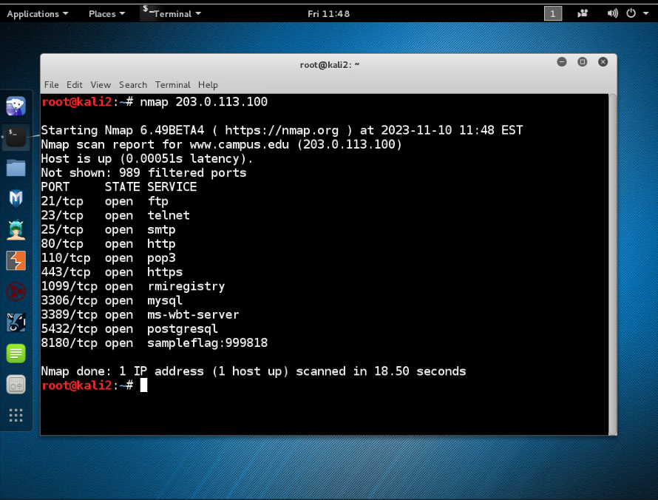

**Step 2:** In command prompt we search for open ports in the firewall for IP Address 203.0.113.100 using **nmap**.

Command: **nmap 203.0.113.100**

Found the **Sample Flag:999818** for TCP port number 8180.

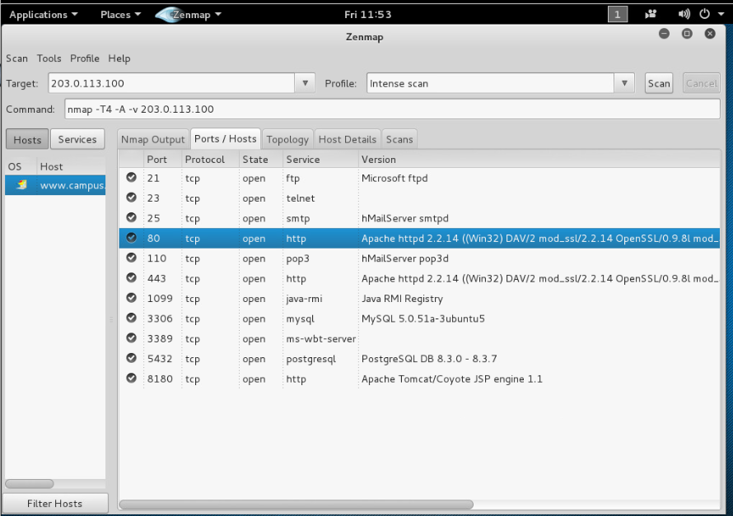

**Step 3:** **Zenmap** Application is then opened from the command prompt using the command: **zenmap**. Once after the application gets opened enter [**203.0.113.100**](http://www.campus.edu) in the Target field and select the scan button to perform the intense scan. After several minutes the number of open ports will be displayed in **Ports/Host Tab**. Then close the zenmap without saving. When you run a firewall scan, take note of the **Apache httpd 2.2.14 (Win32) DAV/2** banner that appears for port 80.

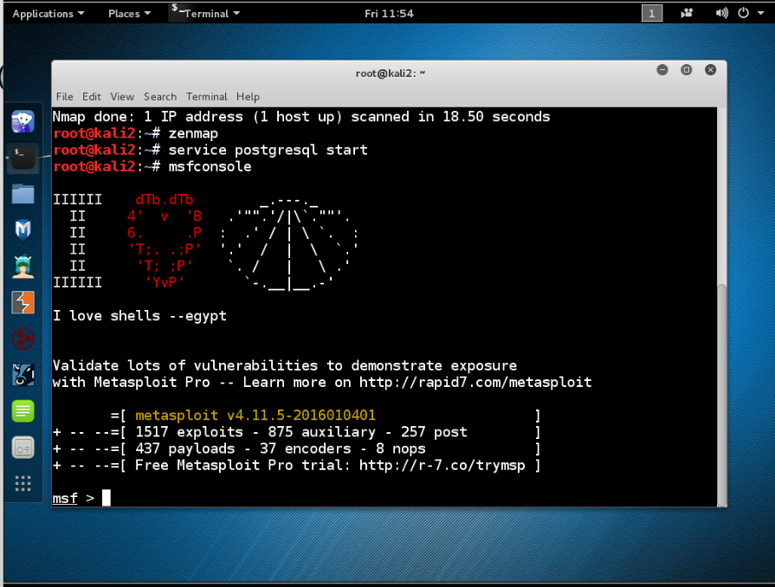

**Attacking the Target**

**Step4:** Get PostgreSQL up and running. Next, open the Metasploit framework's msfconcole.



**Challenge #1:** When entered the banner command multiple times in msf console, captured the **flag2 number:** **776554**.

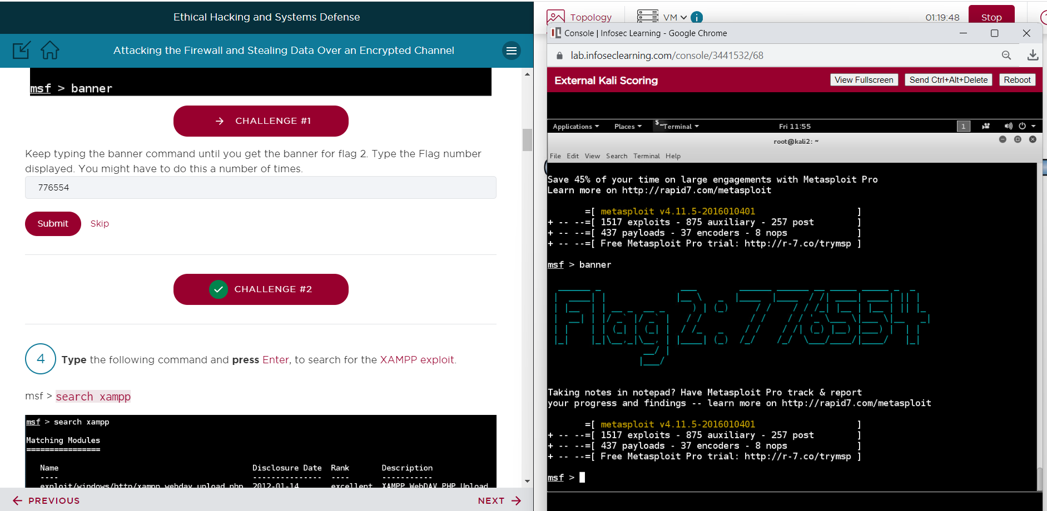

**Challenge #2:** When entered the banner command multiple times in Armitage console, captured the **flag3 number:** **223444**.

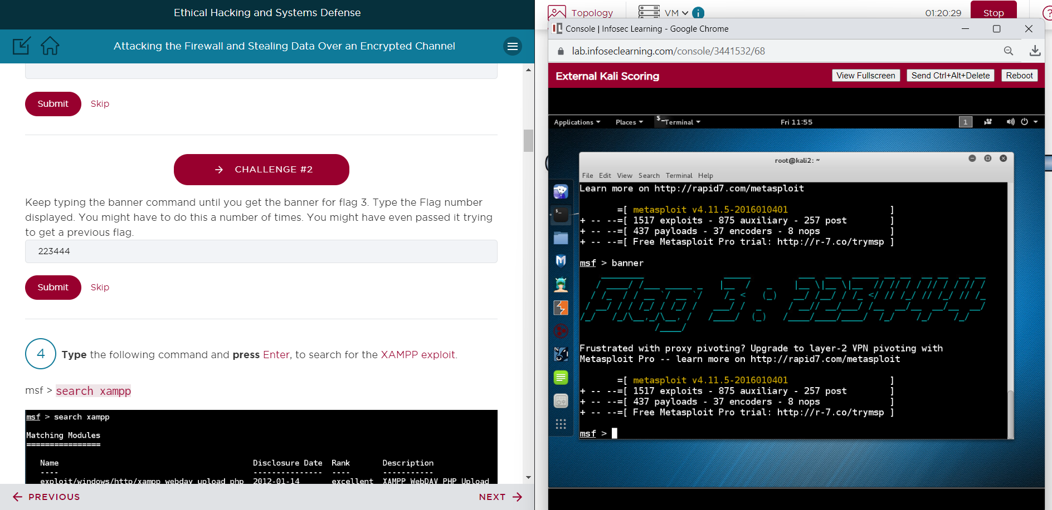

**Step 6:** Look for the exploit for XAMPP. Next, make use of the XAMPP exploit and learn more about it.

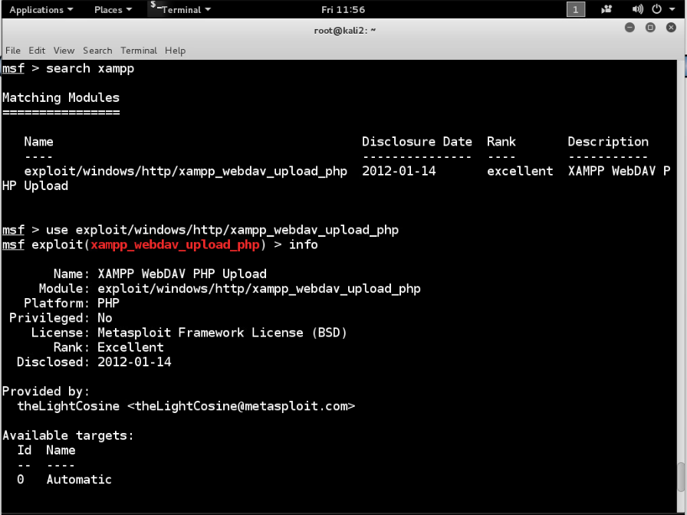

**Step 7:** Assign **203.0.113.100** as the **remote host's** IP address. Assign the payload to a PHP shell that reverses meterpreter. Your local host address should be set to **175.45.176.199**. Next, view the settings that you have selected.

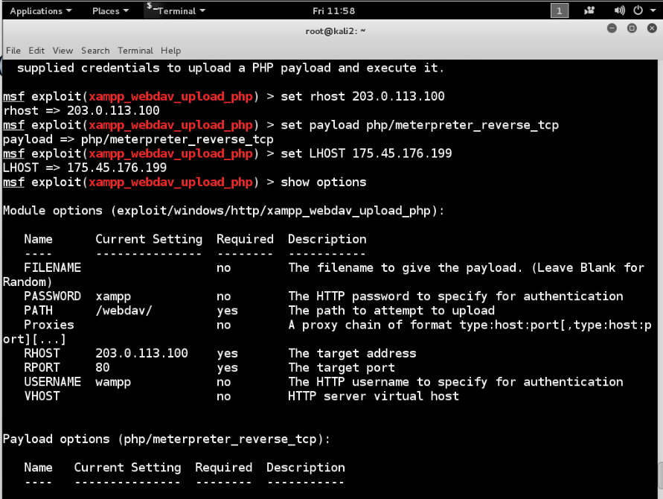

**Step 8:** Take advantage of the remote system.

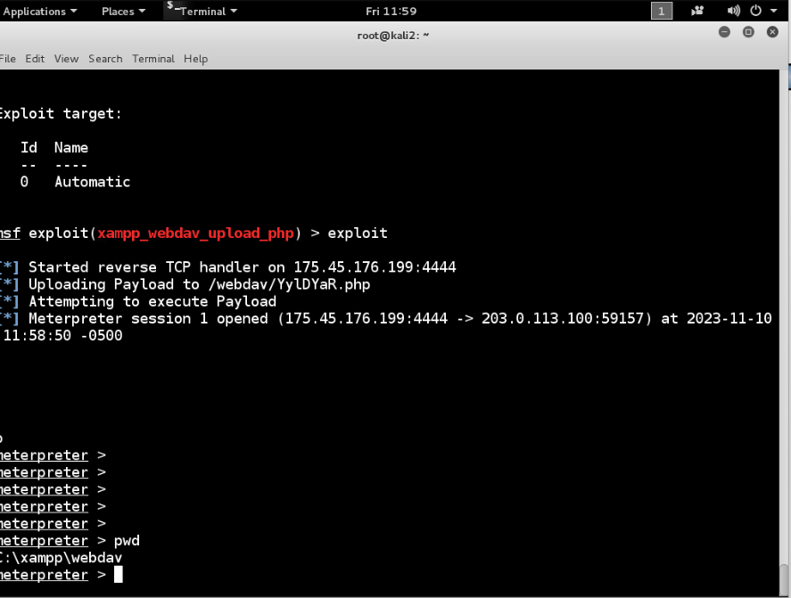

**Step 9:** Navigate to the Apache directory and make a list of all the files and folders currently located there.

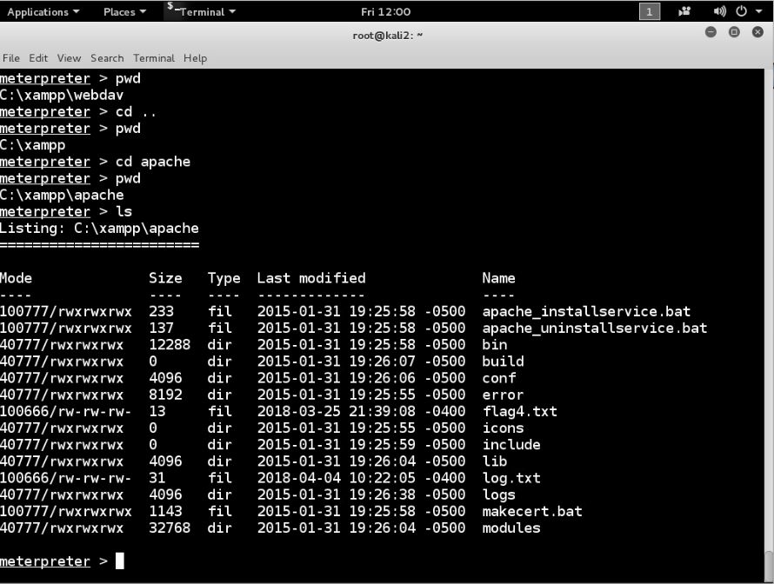

**Step 10:** Examine the file log.txt.

**Challenge #3**: **Captured the flag: 345678** by view the flag4.txt file in logs folder.

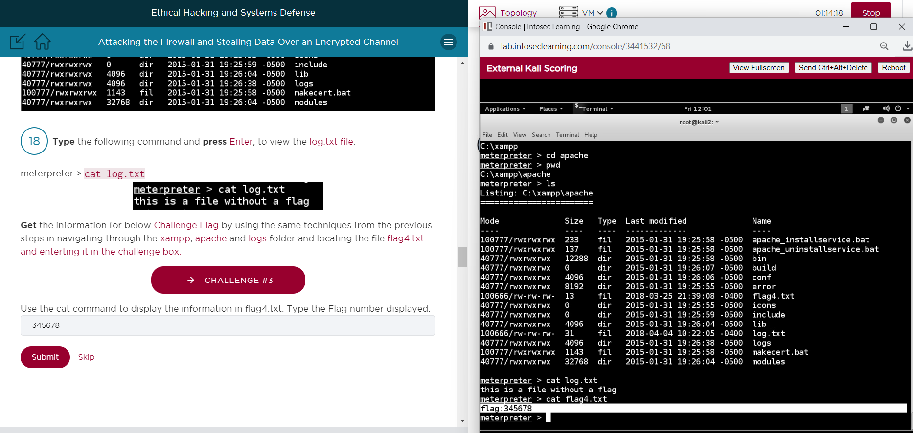

**Step 11:** Navigate to the logs directory and make a list of the current directory's files and folders. Download the access.log file from the compromised system to the Kali Linux-powered attacker PC.

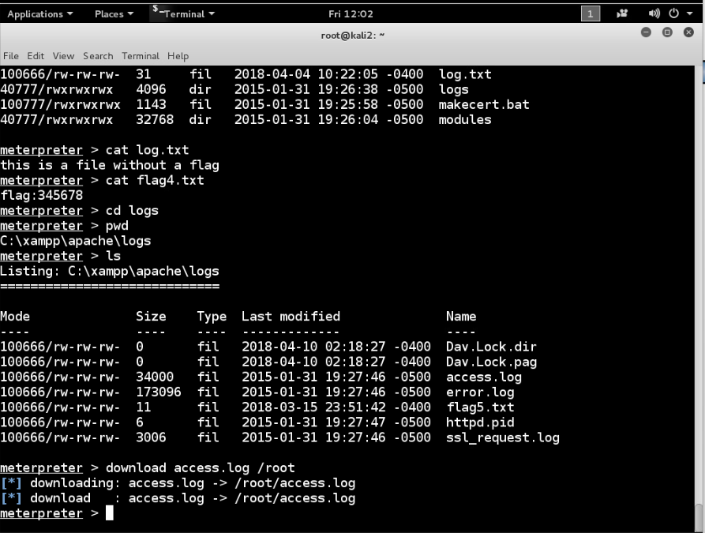

**Step 12:** Open the access.log file by going to the home folder. **192.168.1.30**, also known as an internal address, is the first IP address found in the file, as was observed. **192.168.1.10** is the webserver's internal address.

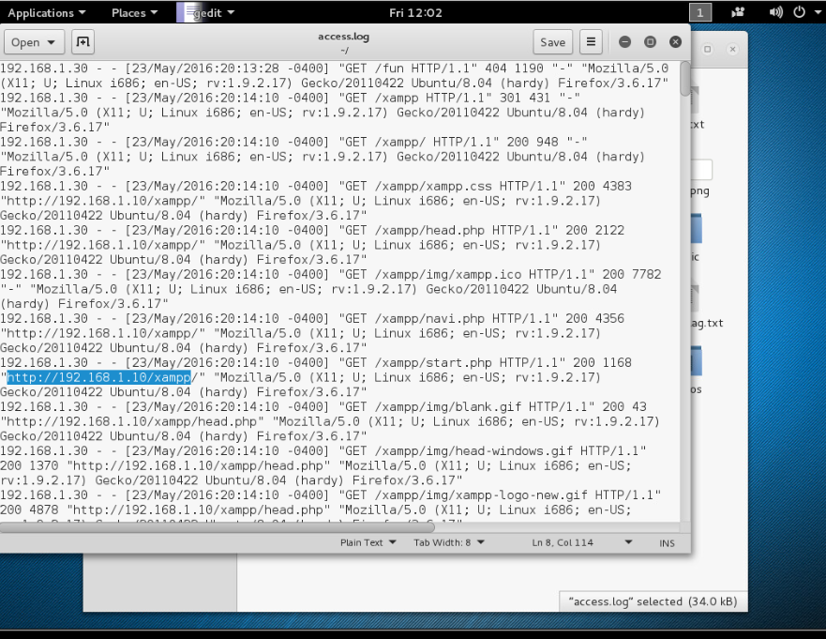

**Local Exploit and Stealing the Data**

**Step 13:** Create a route to the local area network (LAN) of the victim. Ascertain the operating system of the compromised device. Establish a background connection to the victim's computer. Return to the MSSF prompt now. Look for the exploit ms09_050.

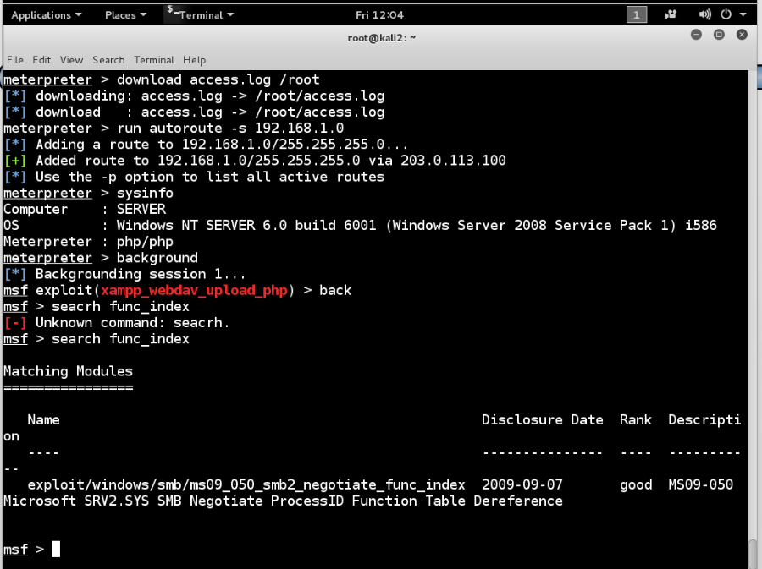

**Step 14**: Utilize the exploit ms09_050. Find out more about the exploit ms09_050.

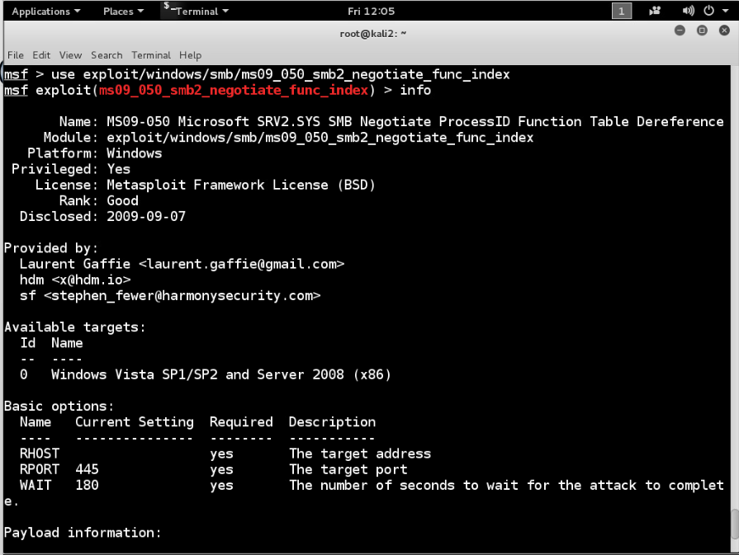

**Step 15:** Configure the remote host's IP address to **192.168.1.10**. Configure Windows Reverse TCP Meterpreter as the payload. A local host of **175.45.176.199** should be set. Next, view the settings that you have selected.

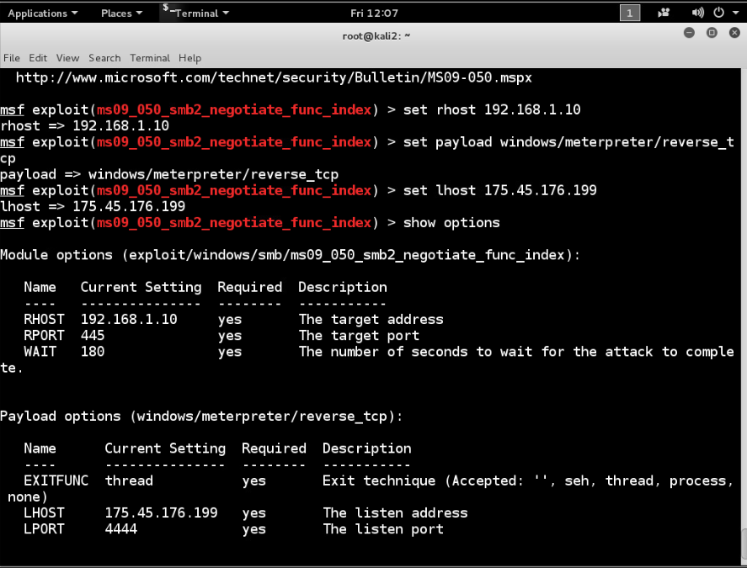

**Step 16:** Make use of the remote system. List every file and folder in the C: directory by going there.

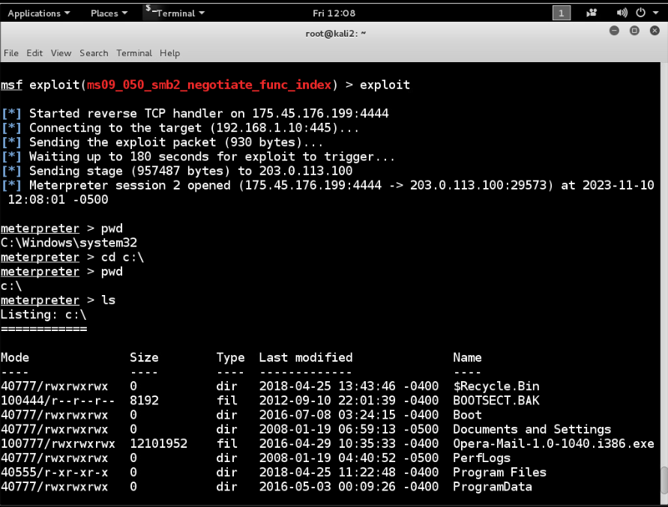

**Step 17:** List every file and folder in the shared directory by going there.

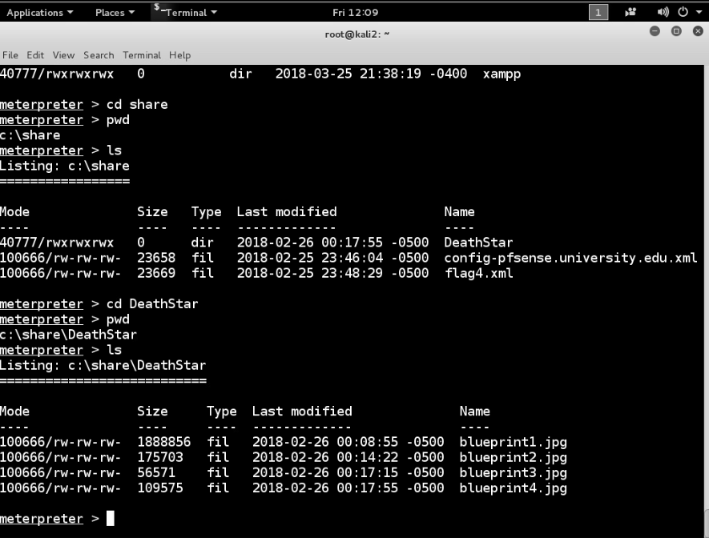

**Step 18:** Next, navigate to the DeathStar directory and make a list of every file and folder within it. Next, download the image files from the compromised system to your Kali Linux-powered attacker PC.

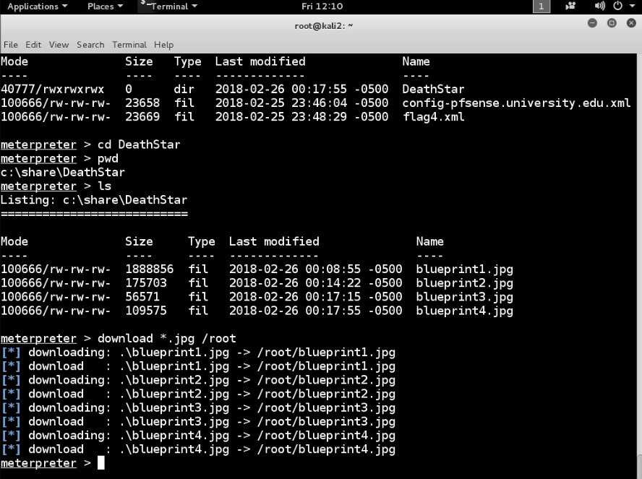

**Step 19:** Navigate to the Home directory, then Check out the designs that were taken from the Deathstar directory.

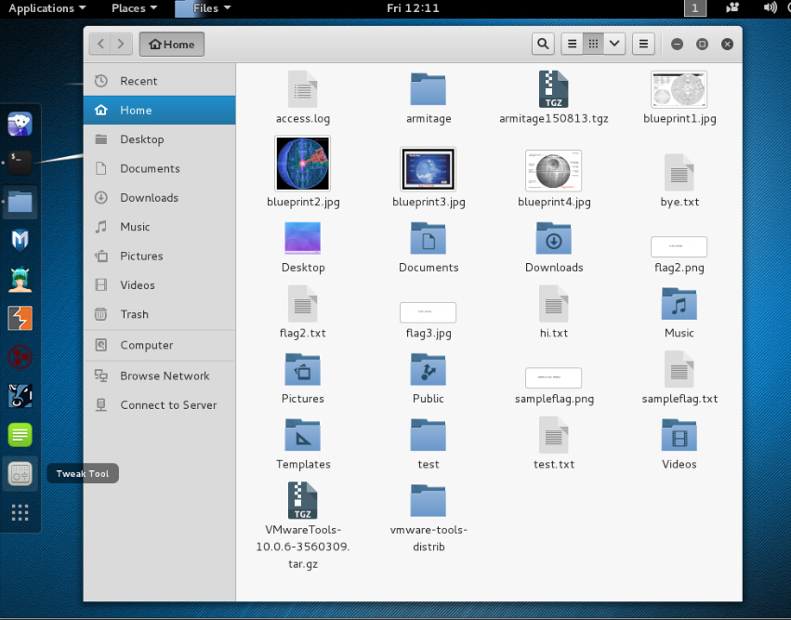

**Challenge #4**: Opened the **Blueprint2.jpg** and **captured the flag: 111222.**

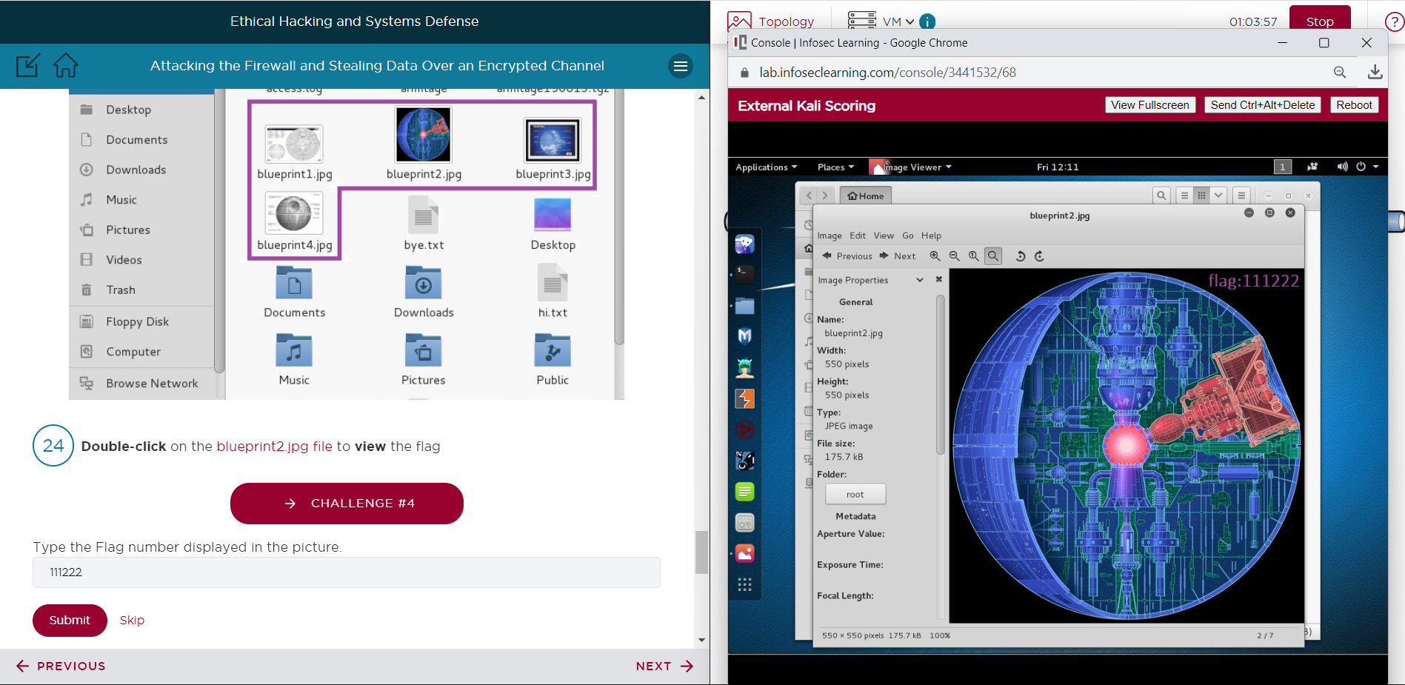

**Challenge #5**: Opened Blueprint3.jpgand **captured the flag: 777558.**

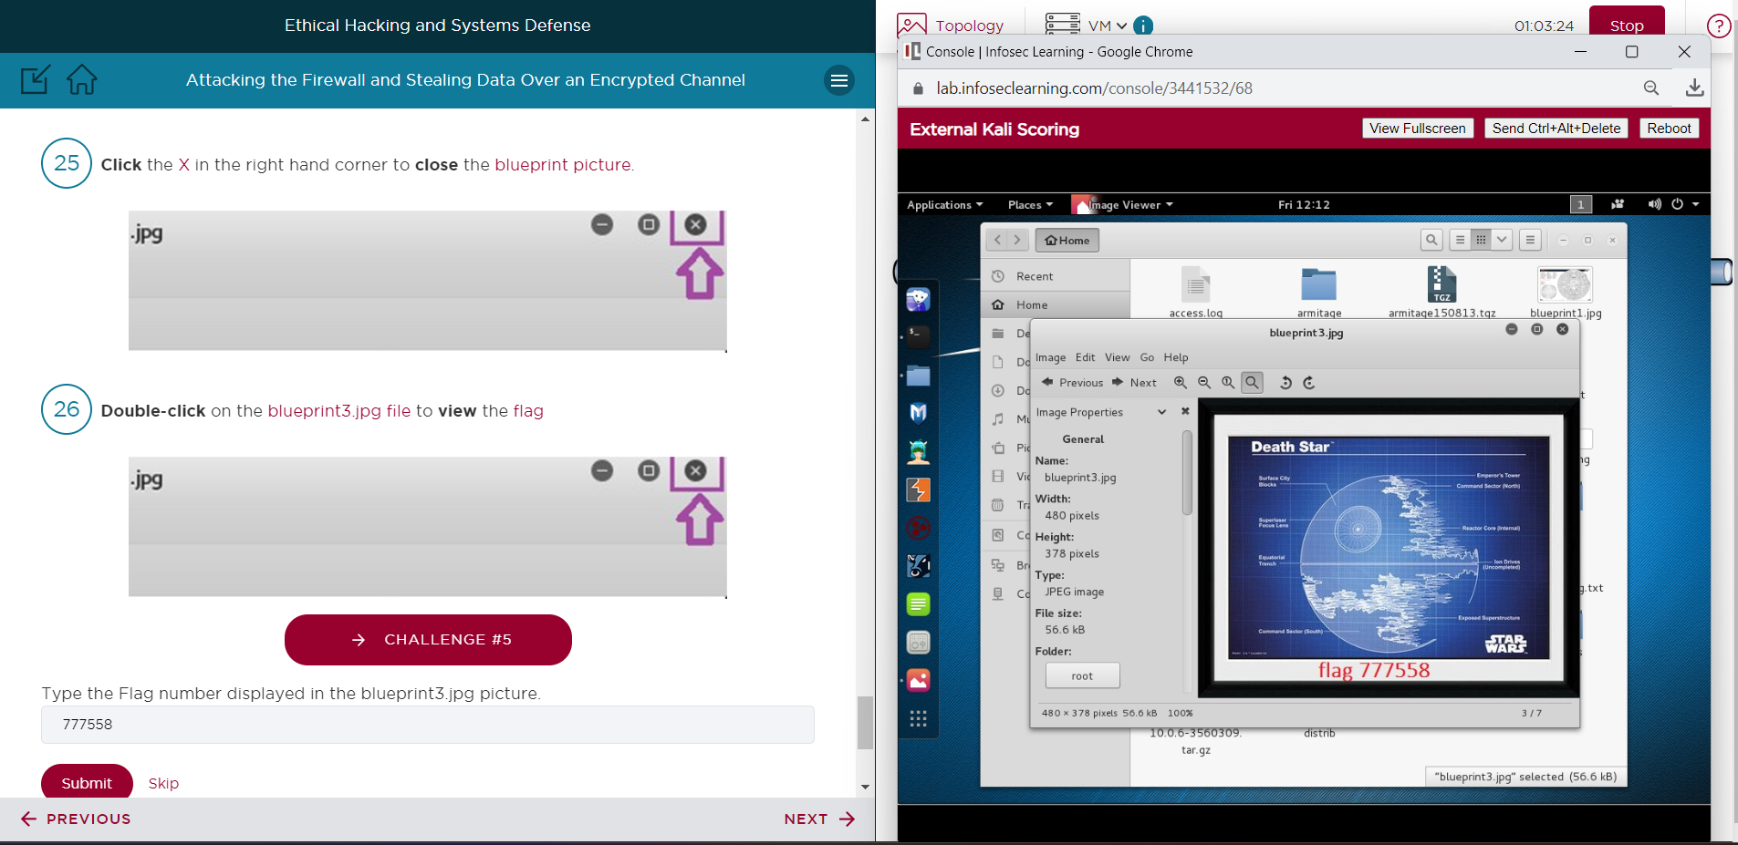

# Supporting Evidence

**Screenshots, Research, Etc.**

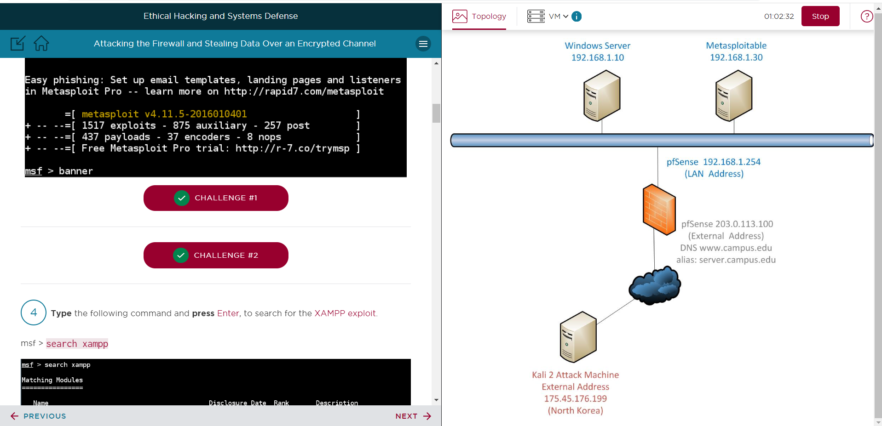

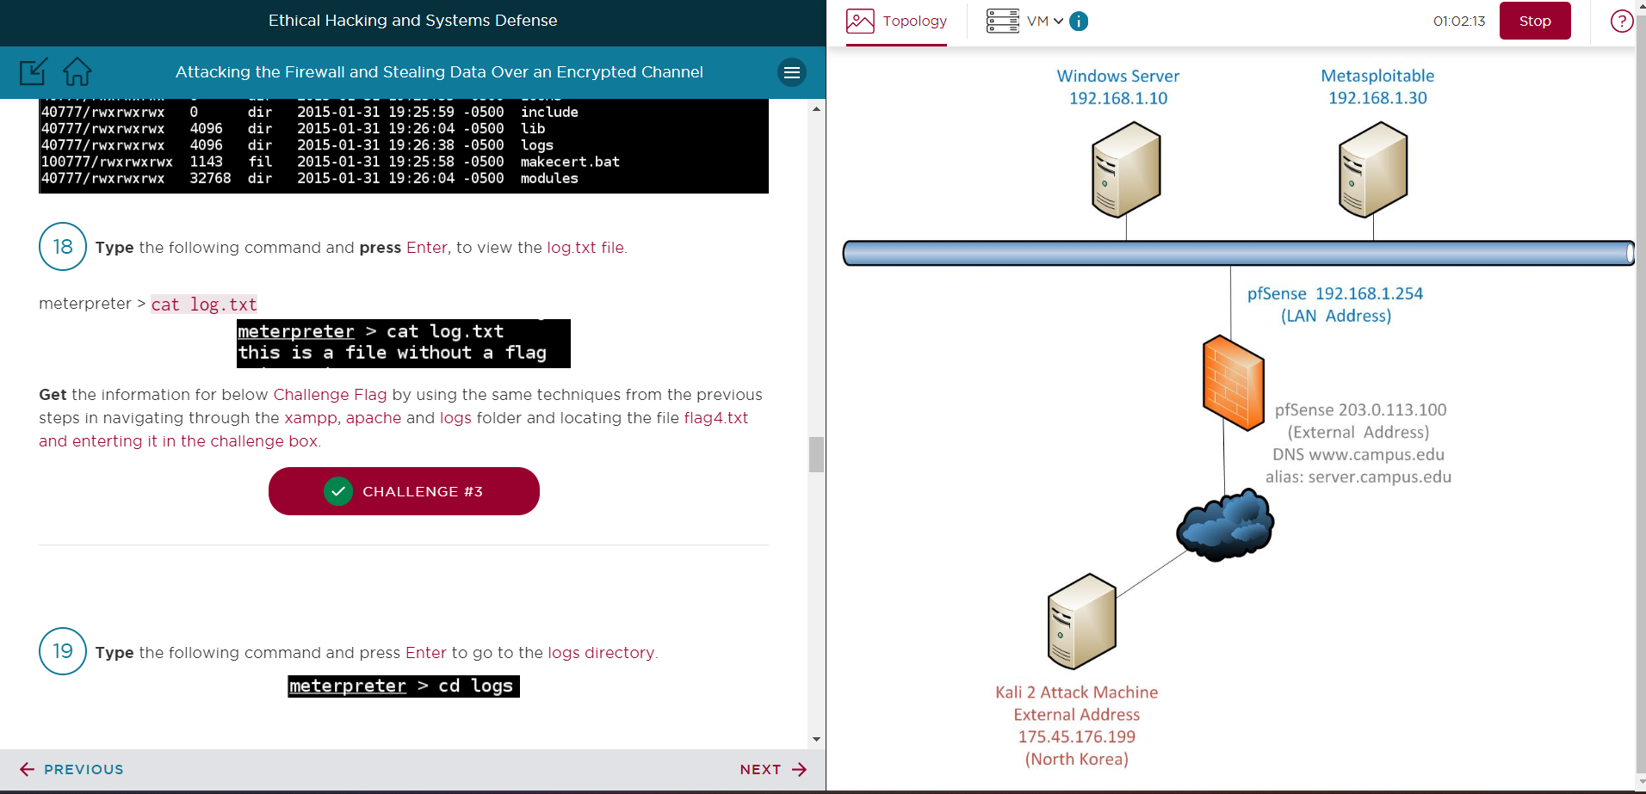

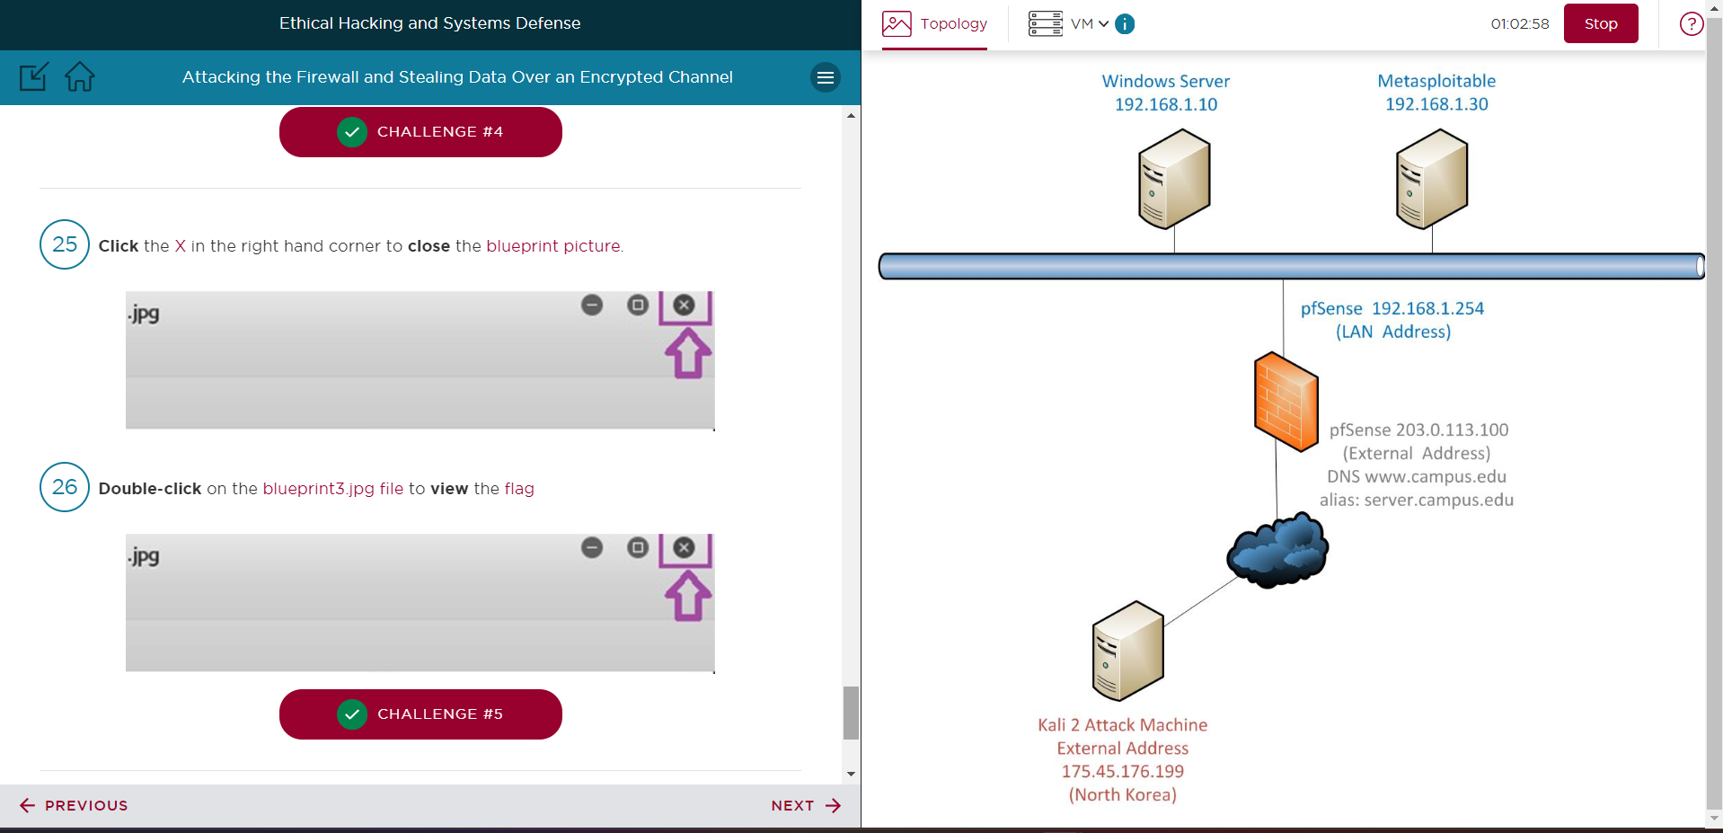

# Conclusion & Wrap-Up

## Summary with observations, Success & Failures, Challenges

The attacker in this lab was able to take use of two vulnerabilities: the Windows Server's MS09-050 SMB vulnerability and the web server's XAMPP WebDAV vulnerability. This made it possible for sensitive data to be stolen over an encrypted channel.

**Observations:**

* An attacker could take advantage of outdated or unpatched vulnerabilities.
* Firewall rules must restrict external networks' access to internal systems.
* Sensitive data should have access controls in place.

**Success:**

* Conducting network penetration tests with Kali Linux tools.
* Switching to target other inside hosts by attacking one compromised system.

**Risks:**

* Data theft: As demonstrated by the theft of the DeathStar designs, attackers can obtain sensitive data by taking advantage of flaws. Depending on the data accessed, this may result in financial fraud, intellectual property theft, or privacy violations.
* Lateral movement: The attacker managed to change course and go from the web server to an internal Windows server. The attacker can increase privileges, persist, and compromise more systems with this lateral movement.
* Service disruption: Vulnerabilities such as MS09-050 may cause a denial of service attack on impacted systems, hence affecting productivity and availability.
* Brand reputation damage: Negative publicity and a decline in customer trust are the results of data breaches and service outages brought on by security breaches.

**Remediations:**

* Patch management: To address known vulnerabilities, operating systems, software, and firmware must be updated and patched on a regular basis. Patch deployment should be done automatically.
* Network segmentation: To prevent lateral movement, the internal network should be divided into security zones using VLANs and firewall rules.
* The least privilege principle Adhere to the least privilege principle and the zero-trust paradigm for all user and service accounts. This reduces the harm caused by hacked credentials.
* Recording and observing: Turn on thorough system and network activity logging. Send logs to a central SIEM so that they may be analyzed and correlated to find attacks.
* Plan for incident response: Establish an incident response strategy to swiftly contain and eliminate threats. Engage in routine IR drills and exercises.